WEB322 Assignment 1

Jason Goldenberg

055160113

Table Of Contents

1………………………………………………………………………………………….…………………………………………………….Title Page

2……………………………………….…………………….…………………………………………………………………….Table Of Contents

3………………………………..…………………………….…………………..………………………………………………………...Server Side

4…………………………….…………………………………………………………………………………………………………….…Homepage

5…………………………………………………………………………………………………………………………………………..RoomListing

6……………………………………………………………………………………………………………………………………………….…Navbar

The server side of my application consisted of Express, Express handlebars and NodeJS. All the requirements were met as I successfully used routing for my pages. An example of routing is below. 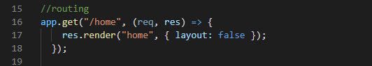

This image contains the routing for my home page.

My homepage consisted of a brief description, a promotional section an image and a booking form. The requirements were met on this part of the assignment. Here is an image of the form I completed: 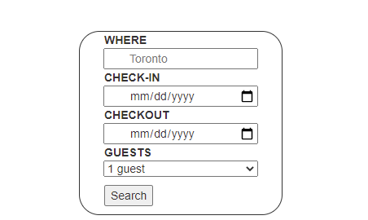

My room listing page contained 6 images in a 3 by 2 grid. The functionality of this section was met. I chose to use placeholder images to make the creation of the grid easier. Below is a snippet of that section. 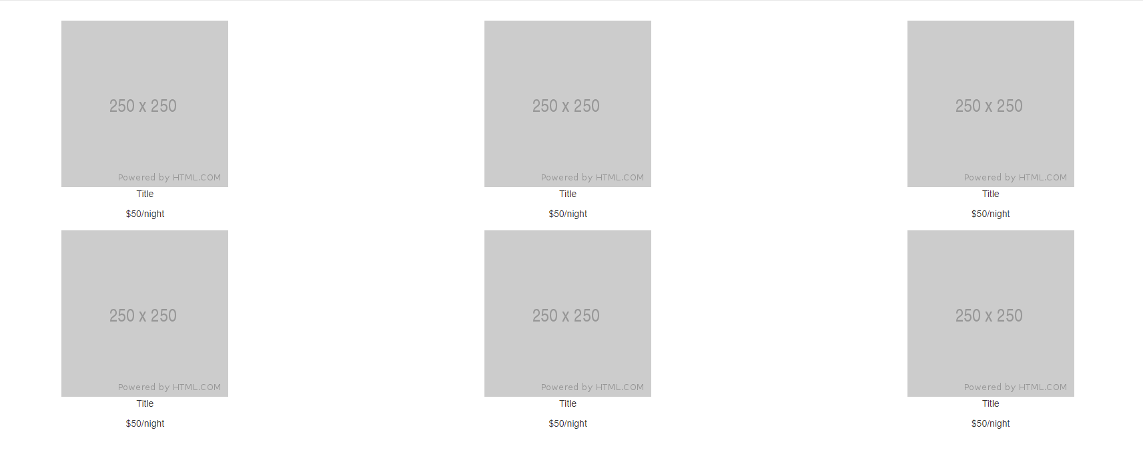

The navigation bar of the website is my favorite. I chose to use bootstrap for it because it seemed to be the most aesthetically pleasing option. The bar contained the logo, two links(home and room listing) and a search bar. On the right side it contained the sign up and login link. Both of these links opened up modals. The functionality of this part may have not been met because I was unsure how to incorporate the handlebars to a modal. Below is a snippet of the Navbar: 